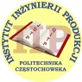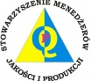
International Scientific Conference International Scientific Conference
"WoodEMA. Visegrad innovations"
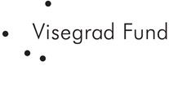
May 29th-31st 2013

Project phases (events calendar):
Since | Untill | Description of the phase
05/2013 | 06/2013 | preparatory works (contacting NGO-s, website advertising, press releases, sending invitations, collecting applications and papers and workshop agenda)
07/2013 | 08/2013 | conference and workshop organization, press releases, evaluation, collecting papers, preparation of the publication
09/2013 | 09/2013 | collecting papers, print of publications in the form of monographs, evaluation of the project results, preparation of the financial settlement and final report for IVF

